Indian School Al Wadi Al Kabir
Computer Applications (Code 165)
First Rehearsal (Theory)

Class: X Date: 07-12-2023
Maximum Marks: 50 Time Allowed: 2 hours
General Instructions:
1. This Question Paper has 5 Sections A-E.
2. All Questions are compulsory. However, internal choices have been provided in some of the questions.
3. Section A has 12 questions carrying 01 mark each.
4. Section B has 7 Short Answer (SA-I) type questions carrying 02 marks each.
5. Section C has 4 Short Answer (SA-II) type questions carrying 03 marks each.
6. Section D has 1 Long Answer (LA) type question carrying 04 marks.
7. Section E has 2 Source based /Case-based /Passage based Questions carrying 04 marks each.

SECTION – A
(All questions are compulsory)
1. Which of the following is the protocol that helps you to communicate between a Web
server and a Web browser?
(a) FTP
(b) TCP/IP
(c) HTP
(d) HTTPS

2. Example(s) of HTML editor is/are
(a) Notepad
(b) Microsoft frontpage
(c) Dreamweaver
(d) All of these

3. Which of the following options is an INVALID attribute of <font> tag in HTML ?
(a) face
(b) width
(c) size
(d) color

4. The default starting value for an ordered list in HTML is _________ .

(a) i
(b) 1
(c) a
(d)

5. Which of the following is a proprietary software?

(a) Python | (c) Linux
(b) Microsoft Windows | (d) MySQL

6. If a third party were to assume ownership, copy or sell someone's previously copywritten work, that would legally be considered. What right was infringed?

(a) Patent
(b) Trademark
(c) Copyright
(d) Plagiarism

7. <! ---- .... ---- > tag is used in HTML for

(a) horizontal line
(b) break line
(c) underline
(d) comment line

8. Riya wants to learn some software skills for which she needs some softwares. But she
does not want to pay for this. Which type of software she should use?

(a) Antivirus software
(b) Microsoft's software
(c) Open source software
(d) Proprietary software
9. Suhani asks her colleague for her project work and then copies the entire work and submits it to her team leader claiming it to be her own work. The act performed by Suhani is known as ____________ .

(a) Phishing
(b) Plagiarism
(c) Spamming
(d) Virus

10. The protocol that is used to send e-mails is __________ .
(a) HTTP
(b) POP
(c) SMTP
(d) FTP
Questions No-11 & 12 are Assertion and Reason types. Each question consists of two statements, namely, Assertion (A) and Reason (R). Select the most suitable option considering the Assertion & Reason.
11.
Assertion (A): Attribute is a special word that specifies additional information for the tag.
Reason (R): Attribute is used inside all the HTML tags.
(a) Both Assertion (A) and Reason (R) are true and Reason (R) is a correct explanation of Assertion (A).
(b) Both Assertion (A) and Reason (R) are true and Reason (R) is not a correct explanation of Assertion (A).
(c) Assertion (A) is true and Reason (R) is false.
(d) Assertion (A) is false and Reason (R) is true.

12.
Assertion (A): CSS saves a lot of work. It can control the layout of multiple web pages all at once.
Reason (R): All the required style settings can be stored in an external stylesheet and a link to it can be added in the section of each web page.

(a) Both Assertion (A) and Reason (R) are true and Reason (R) is a correct explanation of Assertion (A).
(b) Both Assertion (A) and Reason (R) are true but Reason (R) is not a correct explanation of Assertion (A).
(c) Assertion (A) is true and Reason (R) is false.
(d) Assertion (A) is false and Reason (R) is true.

SECTION –B
(2 marks each)

13. Consider the URL:https://www.shiskha.com and answer the following questions:
a. Which component identifies the type of protocol?
b. What is the significance of "s" in https?

14. a) Which software are termed as open-source software? Name any two such software.
OR
b) What do you understand by the term Intellectual property right? Discuss briefly.
15. How is CSS beneficial for web page development ? Give any two points.

16. (a) What is e-Governance ? Write the names of any two services that can be provided
using e-Governance.
OR
(b) What is Internet ? How can we retrieve information from the Internet ?

17. Write the difference between alink and vlink. Write an HTML statement to illustrate the usage of these 2 attributes.

18. (a) Illustrate the use of the radio button input type on an HTML form with an appropriate
code and the corresponding output.
OR
(b) Write the difference between <ol> and <ul> tags in HTML. Also write suitable examples
of each to illustrate the difference.

19. Explain the concept of Submit and Reset buttons in HTML forms.

SECTION –C
(3 marks each)

20. What is the digital divide? Write any two reasons for digital divide in India.
21. a) Write the HTML code to display an image on the left side of the page.
OR
b) Write the HTML code to display a table with a border of 5px.

22. State the difference between Web Portal and Website.
23. Write HTML code to display the unordered list (with square bullets) of two cities “DELHI” and “MUMBAI”. The web page should have a yellow background and the title of the page should be ‘My Cities’
OR
Write HTML code to display an ordered list (with uppercase roman numbers) listing any three subjects being taught in your school The web page should have a red background and the title of the page should be ‘My Subjects’

SECTION –D
(4 marks)

24. Observe the following table and write the HTML code to generate it.
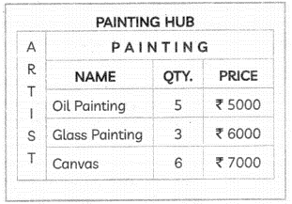

OR
Consider the following webpage and write an HTML code to generate it. Consider the above web page and write a code in HTML to generate it. Consider the specifications as given below. Students can write code for any 4 specifications out of the given 5 specifications.
Useful Links:
- Online shopping with Amazon
- Order your food on Zomato
- Send gifts Ferns on Petals
- Book your movie ticket Book My Show
Specification 1: Heading of the web page should be “Useful Links”.
Specification 2: The heading “Useful Links” should be first level heading.
Specification 3: The web page should contain text exactly as shown in the above image. The words underlined are supposed to be hyperlinks for their respective websites.
Specification 4: All hyperlinks should be marked as bulleted lists as shown in the given image.
Specification 5: The title of the page should be ‘Links in List’.

SECTION - E
(4 marks each)

25.
Case Study 1:

Parminder recently celebrated his 14th birthday. On his birthday he got to know about Facebook. He learned how social networking sites help people to meet their friends and discuss things online. He also found out that he is now eligible to open a Facebook account. He creates his profile on Facebook and starts connecting with his friends.
Within a few days, he befriends many people he knows and many people he does not know. After some time he starts getting negative comments on his posts. He also finds that his pictures are being shared online on objectionable websites.

Based on the given information, answer the questions given below. Attempt any four questions

(A) Identify the type of cybercrime Parminder is a victim of.

(B) After hearing about his ordeal, the school decides to publish a set of moral principles that determines the appropriate behavior of students while using the internet. The school is referring to ……………….. .

(C) Write a safety measure to be taken by Parminder to avoid threats from unknown people in the future.

(D) Parminder decides to make a list of common safety precautions to be taken when online. Write any two points that Parminder should include in his list.
26.
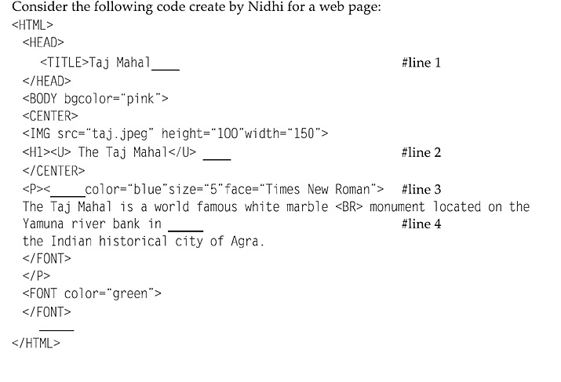

Based on the given code, answer the questions 1 to 4

1. Choose the correct option from the following to fill up in the line 1.
(a) </BODY> (b) </HTML>
(c) </TITLE> (d) None of these
2. Choose the correct option from the following to fill up in the line 2.
(a) <\Hl> (b) </Hl>
(c) </H6> (d) <\H6>
3. Choose the correct option from the following to fill up in the line 3.
(a) FACE (b) FONT (c) CAPTION (d) BODY
4.Choose the correct option from the following to fill up in the line 4.
(a) <HR> (b) <Hl> (c) <BR> (d) <P>

